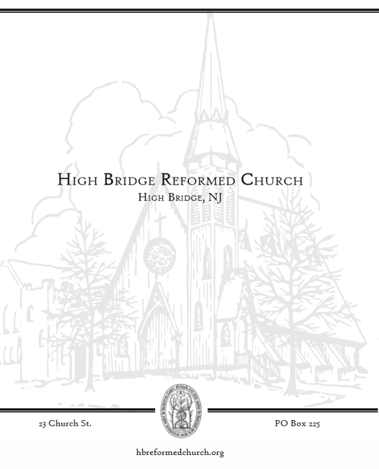

WELCOME!
To all who worship with us this morning: we rejoice that you are here. May God’s Spirit warm our hearts, stir our faith, renew our strength, and refresh our hope. If this is your first time in worship or you are interested in more information, please sign the guest book in the back of the Sanctuary. We look forward to being in touch!

NOTES FOR WORSHIP

Please sign the attendance sheet located in the back when you have a moment before or after service today.
Please remember to fill out a prayer request card if you have anyone you would like to lift up this week.

Meaning of Symbols in the Bulletin
* Please stand if you are able.
Bolded text is spoken by all who are in worship.

Children in Worship
We love kids and welcome all their wiggles and giggles--it is the sound of life! Children learn best by imitation and play, therefore it is vital they be in worship and see adults modeling their faith. We offer a brief “message for all ages” for our children. In the foyer at the back right of the Sanctuary there are children’s bags in a basket on the bookshelf. Your children are welcome to get up and move around as need be.

Assisting in Worship This Morning:
Music Director: Landon Peer

ORDER OF WORSHIP
Fifth Sunday of Easter
Sunday, May 7, 2023
Pastor Ed Staats

✞

GOD GATHERS THE CHURCH

PRELUDE
WELCOME
VOTUM

Leader: Our help is in the name of the Lord who made heaven and earth.
People: Amen.

CALL TO WORSHIP

Leader: The Lord is our refuge.
People: We can find peace in God’s abiding love.

Leader: When troubles assail us, we call upon the Lord.
People: When joys abound, we call upon the Lord.

Leader: Welcome this day to God’s house, one of many dwellings of the Almighty One.
People: We thank you and praise God for his refuge and sanctuary. AMEN.

SALUTATION

Leader: Grace to you, and peace, from God our Father, and the Lord Jesus Christ.
People: Amen

*HYMN #444 I Love to Tell the Story (v.1-3)

CALL TO CONFESSION

PRAYER OF CONFESSION (unison)
People: Gracious and loving God, open our hearts so that we are able to admit to you the fullness of our lives – that which is beautiful and good, and that which is hurtful and hateful. We confess that we do not follow Jesus in all that we do. We love with condition. We judge and condemn. We cast the first stone, and keep the logs in our own eyes. We do not turn to You as the source of our healing. Forgive us, we pray. Forgive our sin, and empower us to be imitators of Christ in love and service. Amen.
A silence is kept for personal reflection

WORDS OF PARDON Psalm 13: 5-6
*EASTER GLORIA
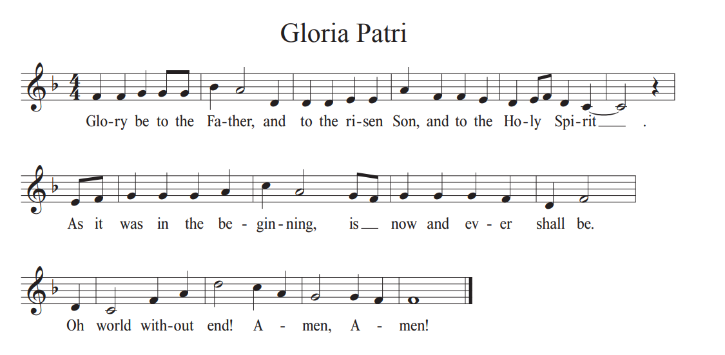

GOD’S WORD IS PROCLAIMED

*CHRISTIAN GREETING
Leader: The peace of Christ be with you
People: And also with you!

SCRIPTURE READING John 14: 1-14

Leader: This is the Word of the Lord
People: Thanks be to God.

SERMON “The Center”
OUR RESPONSE TO GOD

AFFIRMATION OF FAITH: APOSTLES CREED
All:
I believe in God the Father almighty, maker of heaven and earth;
And in Jesus Christ, his only Son, our Lord;
who was conceived by the Holy Spirit,
born of the virgin Mary,
suffered under Pontius Pilate,
was crucified, dead, and buried.
He descended into hell.
The third day he rose again from the dead.
He ascended into heaven,
and sitteth on the right hand of God the Father almighty.
From thence he shall come to judge the quick and the dead.
I believe in the Holy Spirit,
the holy catholic church,
the communion of saints,
the forgiveness of sins,
the resurrection of the body,
and the life everlasting. Amen.”

*HYMN Insert Come and Find the Quite Center

RECEPTION OF OUR GIFTS AND OFFERINGS

*THE DOXOLOGY #815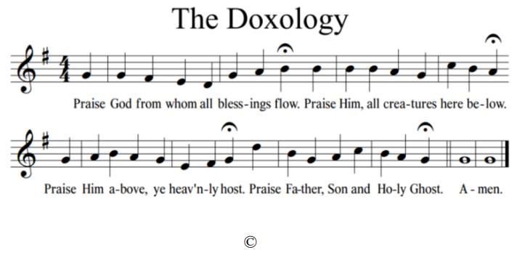

THE LORD’S SUPPER

PRAYERS OF THE PEOPLE & THE LORD’S PRAYER
Leader …We pray all these things in the name of Jesus, who taught us to pray and prays with us saying:

People: [Lord’s Prayer]
Our Father, who art in heaven, hallowed be thy name, thy kingdom come, thy will be done, on earth as it is in heaven. Give us this day our daily bread. And forgive us our debts, as we forgive our debtors. And lead us not into temptation, but deliver us from evil. For thine is the kingdom, and the power, and the glory, forever. Amen.

*HYMN #624 His Eye Is on The Sparrow

BENEDICTION

CHORAL BENEDICTION #358 Because He Lives (Refrain)

*POSTLUDE

OUR LIFE TOGETHER
- Happy Birthday Alison (5/4), Noah (5/7), Ryan (5/8) Jane (5/9)!
- Happy Anniversary Darron and Robyn (5/11)!

- Please join us today for cookies and coffee and fellowship after worship.

- May’s Mission Activity is Cookies for Soldiers. We will be packaging cookies during coffee hour on May 21. If you would like to donate cookies, please let Jessica know.

- There is a new sign-up sheet for volunteers for usher duty in the back. (Jessica apologizes for misplacing the last list). If you are interested in helping usher, please sign up. Jessica will put a schedule together.

- Women For HB is collecting used books to sell during the town wide garage sale. Money earned from the sale goes to HB student scholarships. Books can be dropped in the Jellybean box in the back any time before noon on Friday May 19, 2023.

- You're invited! Join members of the RCA restructuring team and GSC staff leadership for a denomination-wide, virtual event on Thursday, May 11, at 8:00 p.m. Eastern. During this time, attendees will hear what the restructuring team has been working on and the outcomes around which they feel called to restructure, after much discernment. Attendees will have the ability to ask questions and provide feedback on what is presented in the Zoom chat. This invitation is for all RCA members, especially young people with a heart for the RCA's future. RSVP is required. To register, use this link: www.rca.org/virtual-roundtable.

- The next Consistory meeting will be held 5/17 at 7p.

- Our Classis has asked that we spend time in prayer for a fellow church each week. This week, please pray for Three Bridges Reformed Church, in Three Bridges, NJ. We pray for the congregations’ health and wellness in mind, body and spirit.

